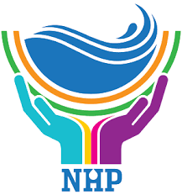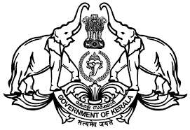

NATIONAL HYDROLOGY PROJECT

GROUND WATER DEPARTMENT

GOVERNMENT OF KERALA

WORKSHOP ON PROGRESS OF PDS STUDY

“ENVIRONMENTAL IMPACT ASSESSMENT OF PESTICIDES IN CARDAMOM CULTIVATING AREA, IDUKKI”

DATE: 25.08.2021
10:30 AM - 10:40 AM – WELCOME SPEECH – A.G. Gopakumar, Suptd. Hydrogeologist & Nodal Officer [NHP]
10:40 AM-10:50 AM – PRESIDENTIAL ADDRESS, SRI. John.V. Samuel IAS
10:50 AM – 11AM - INAGURATION – DR A.K. LOHANI, Scientist G & Head, Surface Water Hydrology Division, NIH, Roorkee
11 AM – 12 PM – PRESENTATION – DR BINDUMOL G.P, Executive Chemist, RAL, Ernakulam
12 PM – 12:15 PM – DISCUSSION
12:15 PM –Vote of thanks - DR SREEKALA M S, JUNIOR Chemist (HG).
..........................................................................................................................................................................

